Lab 5: Examining the Registry
What You Need for this lab
  - Install Virtualbox : https://www.virtualbox.org/wiki/Downloads
  - Install Kali 2021.4. : https://old.kali.org/kali-images/kali-2021.4/
    - Notes: Suggest You configure the disk size of Kali VM 80G because the size of each leakage cases image is 30G+
    - Add new virtual hardisk size 20 GB
  - Tools RegRipper 3.0
  - Download DD images
- https://www.dropbox.com/s/u4axlx8eomgwfdc/cfreds_2015_data_leakage_pc.7z.001
- https://www.dropbox.com/s/pyq50s2cri6yftf/cfreds_2015_data_leakage_pc.7z.002
- https://www.dropbox.com/s/cxvzuiupmqc7l99/cfreds_2015_data_leakage_pc.7z.003
Step 1.
Unzipped the DD image
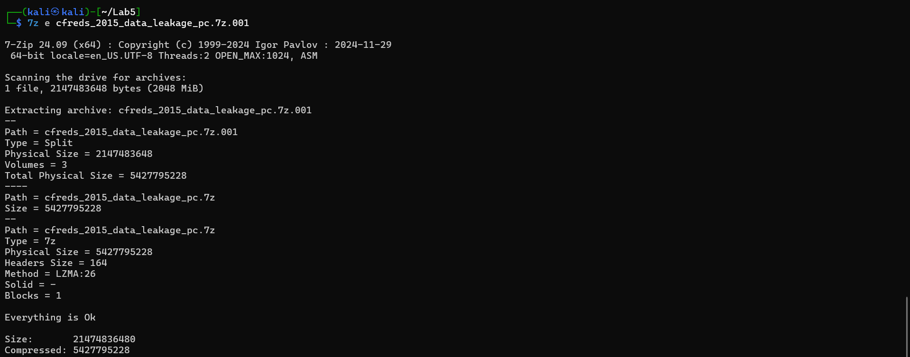

Verify the unzipped DD image
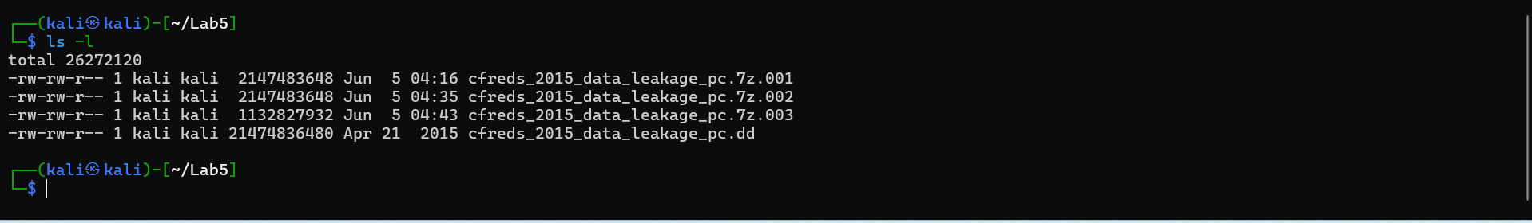

Verify the unzipped DD image with MD5
Step 2.
Exam partitions of the DD image using fdisk
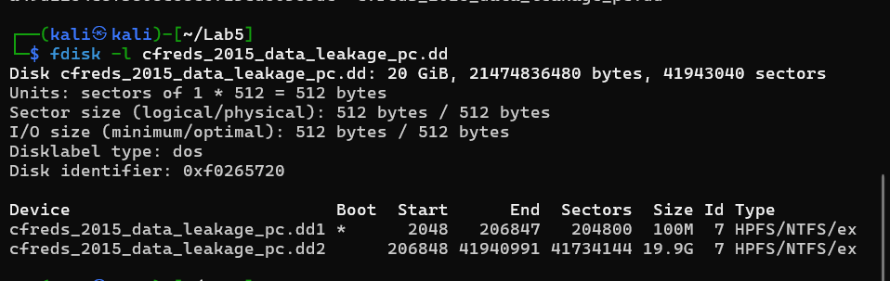
List file/directory names of the system volume
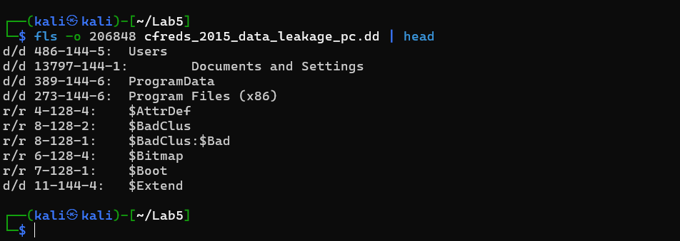
If your VM doesn’t support auto-mounting
Create a folder as the mount point
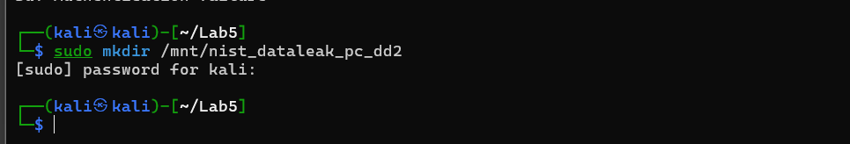
Mount partition 2 to the mounting point
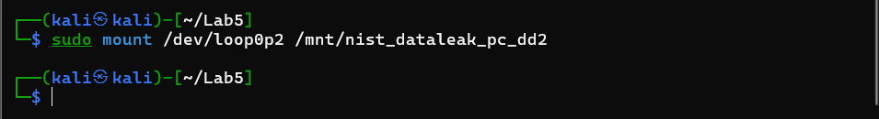

Copy HKEY_LOCAL_MACHINE (Hive) files to \lab
Verify five files
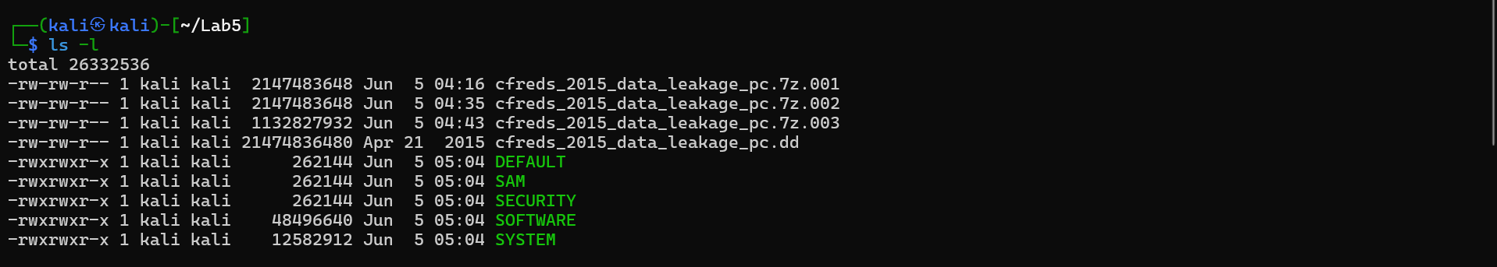
Step 3.
Verify you have the dd image
Compute MD5 and SHA1 of the DD image
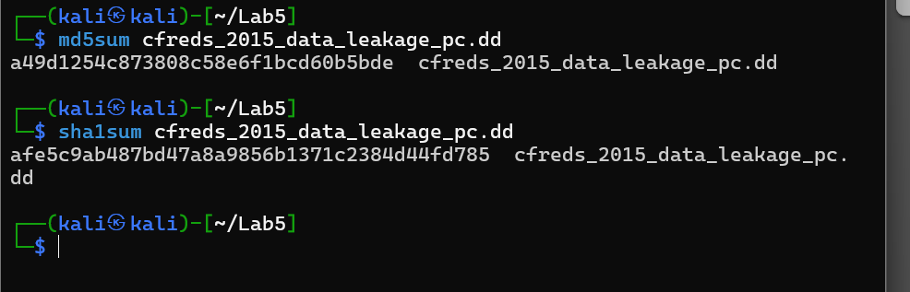
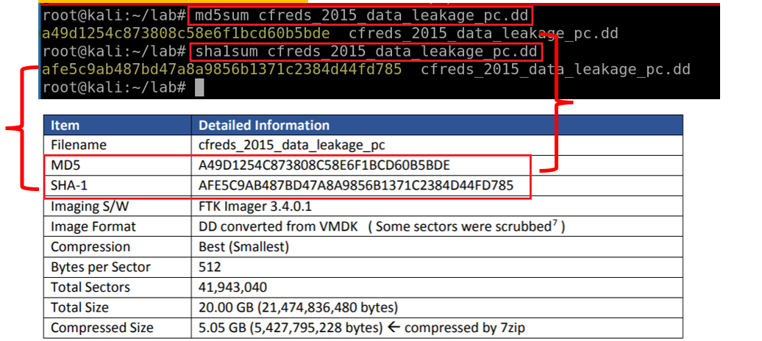

Show partitions of the image
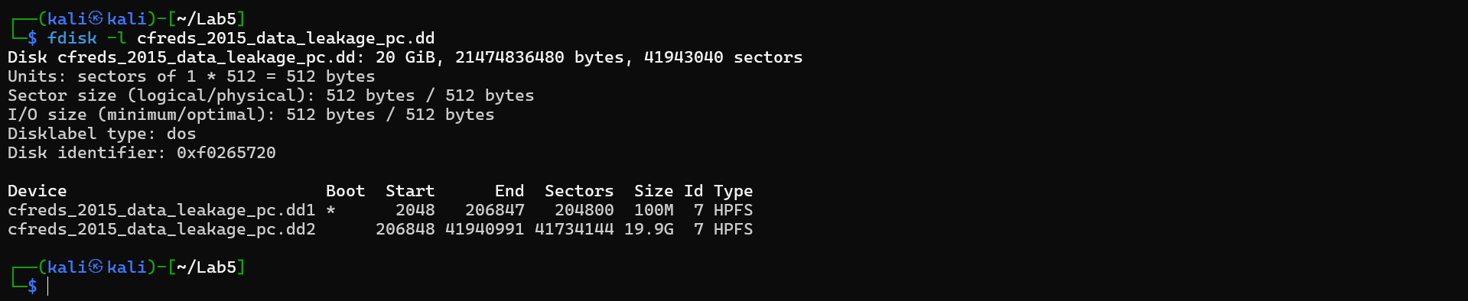
Show partitions and unallocated space using mmls
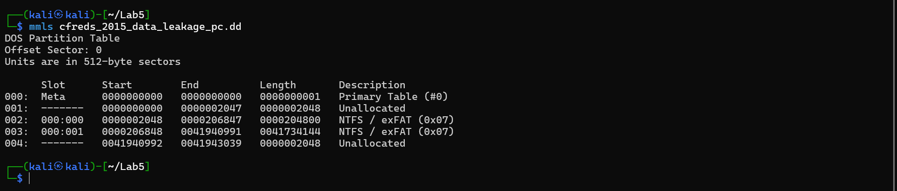
Display file system statistics and metadata information from a disk image (first partition)
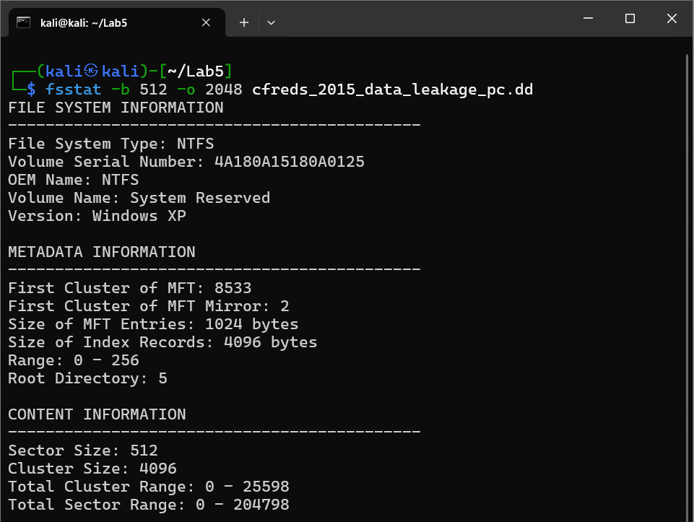

List the second partition details
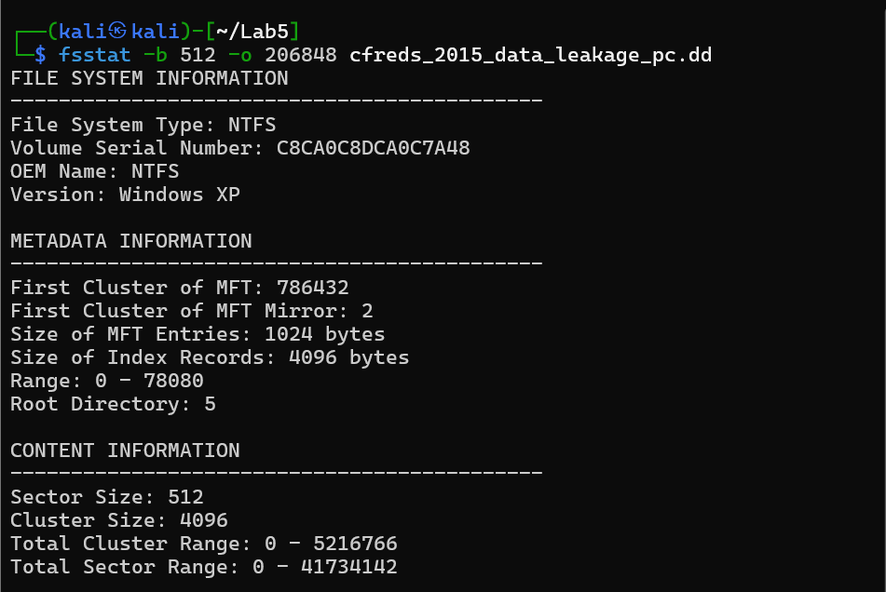
List all deleted .docx files in the whole partition?
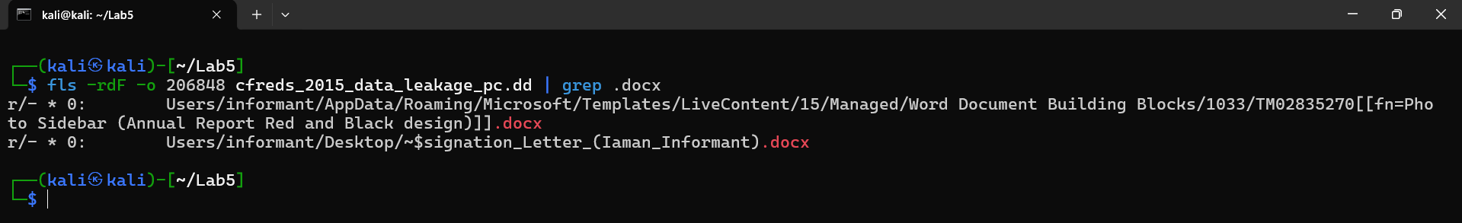
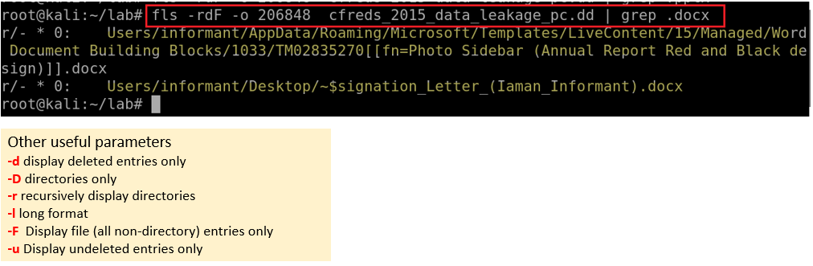

Verify system information
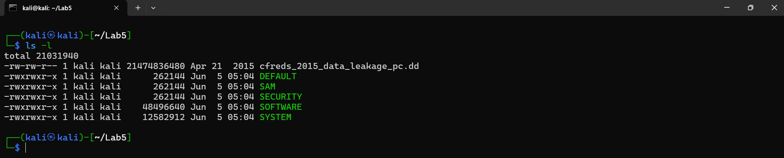
Verify Users’ information
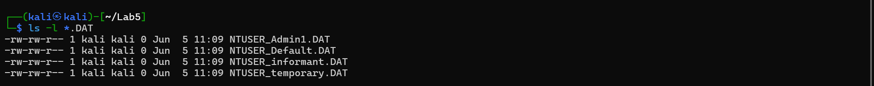
What is the installed OS information in detail?
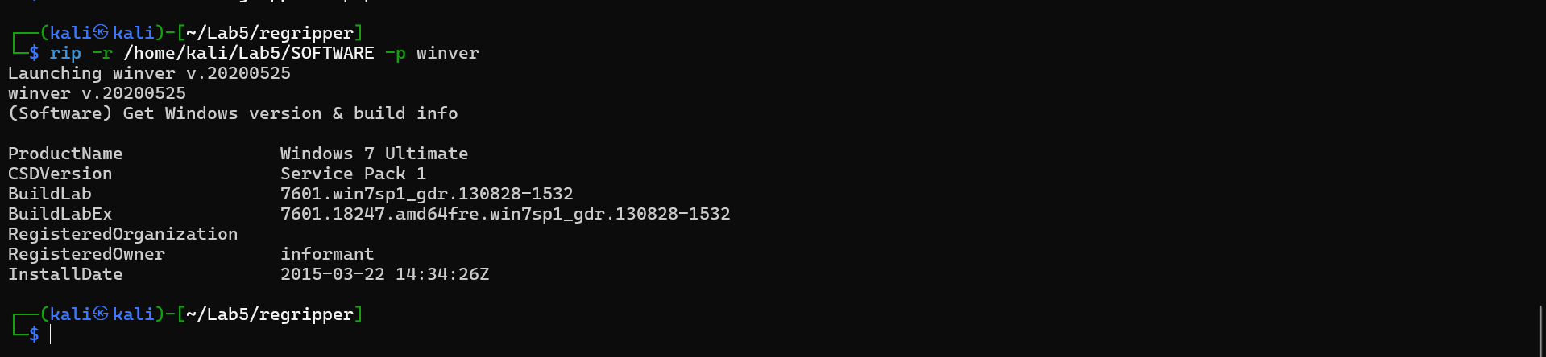
What is the computer name?
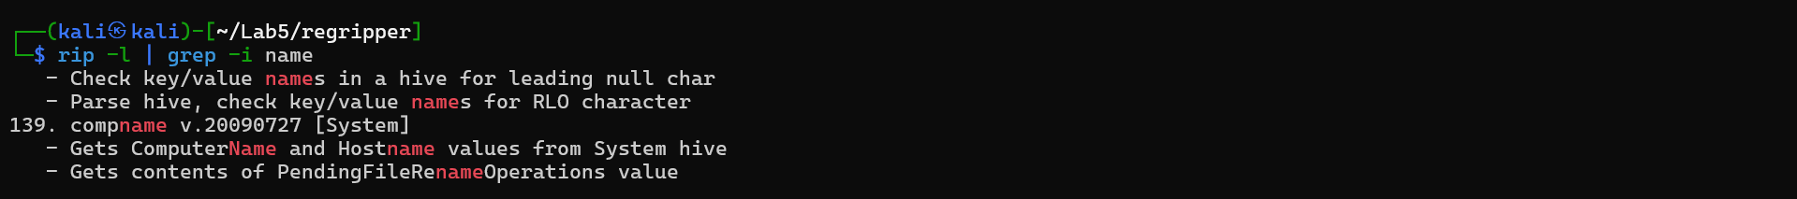
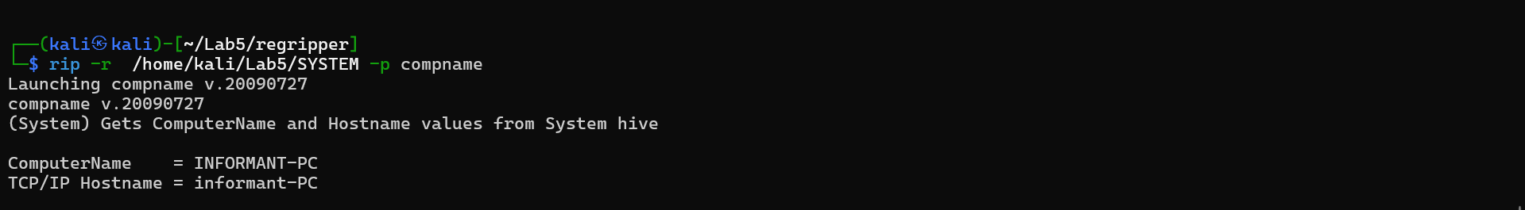

How many accounts does the system have?
Search for profiles
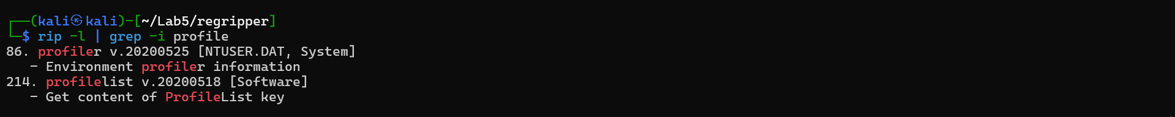
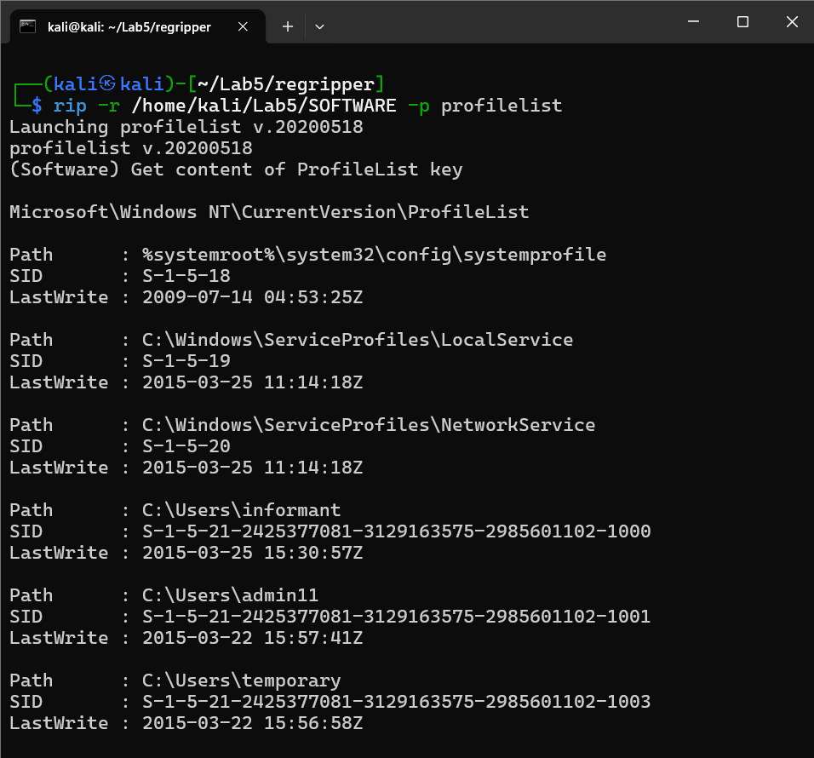

Find and search for Security Accounts Manager (SAM) information
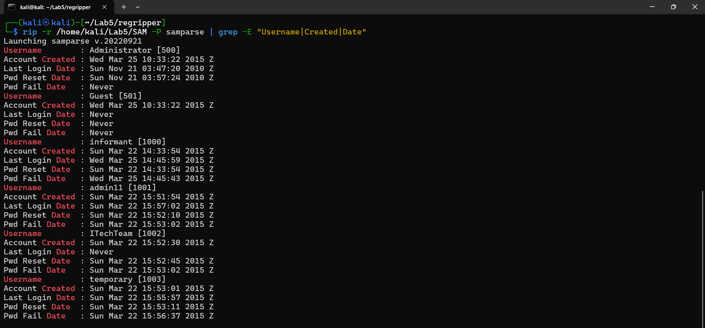
How many accounts does the system have?
The system has 6 user accounts in total:
- Administrator [500]
- Guest [501]
- informant [1000]
- admin1l [1000]
- TTechTeam [1002]
- temporary [1003]

When is the login time?

1. Administrator [500]
- Last Login Date: Sun Nov 21 03:47:20 2010 Z
  - This is the most recent login among all accounts.
  - The account was created on Wed Mar 25 10:33:22 2015 Z, meaning it was used 5 years before its creation date, which suggests a possible time zone discrepancy or system clock error.
  - Password Reset Date: Sun Nov 21 03:57:24 2010 Z (shortly after login).
  - Failed Login Attempts: Never.

2. Guest [501]
- Last Login Date: Never
  - The Guest account was created on Wed Mar 25 10:33:22 2015 Z but has never been used for login.
  - This is typical for default disabled guest accounts in Windows.

3. informant [1000]
- Last Login Date: Wed Mar 25 11:05:59 2015 Z
  - This login occurred shortly after account creation (Sun Mar 22 11:33:54 2015 Z).
  - Failed Login Attempt: Recorded on Wed Mar 25 11:05:43 2015 Z (just 16 seconds before successful login).
  - Possible scenario: User entered a wrong password once before logging in correctly.

4. admin1l [1000]
- Last Login Date: Sun Mar 22 15:57:02 2015 Z
  - Logged in 5 minutes after creation (Sun Mar 22 15:51:54 2015 Z).
  - Failed Login Attempt: Sun Mar 22 15:53:02 2015 Z (4 minutes before successful login).
  - Password Reset: Sun Mar 22 15:52:10 2015 Z (immediately after creation).

5. TTechTeam [1002]
- Last Login Date: Never
  - Created on Sun Mar 22 15:52:30 2015 Z, but no recorded logins.
  - Password Reset: Sun Mar 22 15:52:45 2015 Z (15 seconds after creation).
  - Failed Login Attempt: Sun Mar 22 15:53:02 2015 Z (likely an incorrect manual entry).

6. temporary [1003]
- Last Login Date: Sun Mar 22 15:55:57 2015 Z
  - Logged in ~3 minutes after creation (Sun Mar 22 15:53:01 2015 Z).
  - Failed Login Attempt: Sun Mar 22 15:56:37 2015 Z (40 seconds after the last login, suggesting a post-login lockout).

Who was the last user to logon into PC?
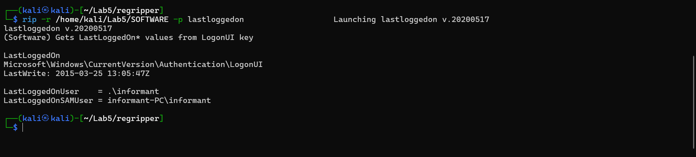

When was the last recorded shutdown date/time?
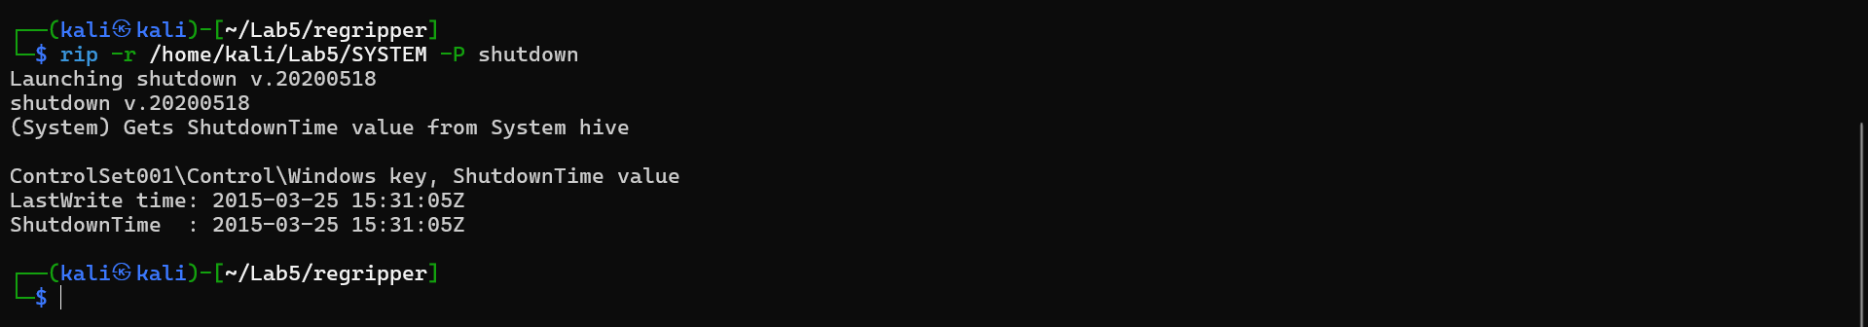

Explain the information of network interface(s) with an IP address assigned by DHCP.
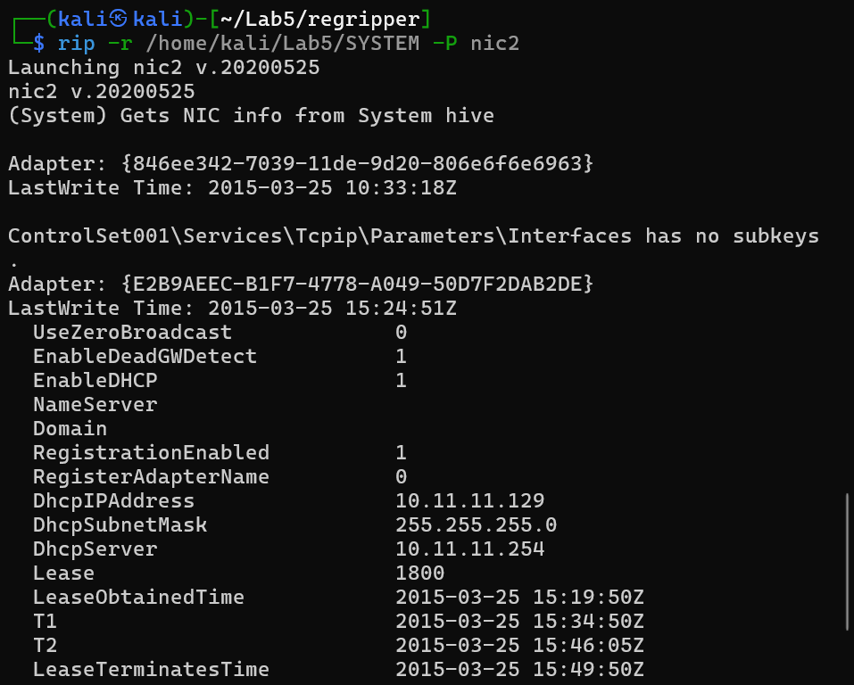

YOU MUST SUBMIT A FULL-SCREEN IMAGE FOR FULL CREDIT!
Save the document with the filename "YOUR NAME Lab 5.pdf", replacing "YOUR NAME" with your real name.
Email the image to the instructor as an attachment to an e-mail message. Send it to: xxx@fe.edu.vn with a subject line of "Lab 5 From YOUR NAME", replacing "YOUR NAME" with your real name.

